SIMATS ENGINEERING (SAVEETHA SCHOOL OF ENGINEERING)
Department of Computer Science and Engineering
ASSESSMENT TOOL 2 – SCENARIO BASED ASSESSMENT (2 Questions)

Course Code: | ITA0502 | Course Title: | COMPUTER VISION
CO Assessed: | CO2 – Manipulation (BL3) | Assessment: | Assessment Tool 2 – Scenario Based Assessment
Weightage: | 20% of CIA | Total Marks: | 20 (2 Questions × 10 Marks)
CO5 Statement: | Apply image enhancement and segmentation techniques for extracting meaningful regions from images.(BL3)
Student Name: | P.Moshiya | Reg. No.: | 192572142
Section / Batch: | SLOT C / 2025 | Date:

Code of Conduct
I P.Moshiya (192572142) certify that this submission is my original work and that I have adhered to the guidelines specified for this assessment. I understand that any violation of academic integrity rules will result in disciplinary action.

Signature of the Student: P.Moshiya

Instructions
- This test contains 2 questions, each carrying 10 marks. Total: 20 Marks.
- No negative marking. Unanswered questions carry zero marks.
- No calculators or electronic devices permitted.
- Duration: 60 minutes.

Section / Topic | Focus Area | Q. Nos. | Marks
Frequency Domain Image Enhancement | Periodic noise removal, Fourier Transform, notch filtering, quality inspection | 1 | 10
Spatial Filtering & Edge-Preserving Enhancement | Bilateral filtering, edge preservation, autonomous vehicle navigation | 2 | 10
GRAND TOTAL: |  | 20 Marks

Annexure A – Scenario Based Assessment

Scenario 1: Manufacturing Quality Inspection
An automated quality inspection system captures images of metal components. Electrical interference introduces repetitive horizontal stripes across the images, making defect detection unreliable.
(a) Interpret the scenario and identify the type of noise present.
(b) Explain how this degradation affects inspection accuracy.
(c) Recommend an appropriate enhancement technique to remove the interference.
(d) Justify why your selected approach is more suitable than spatial-domain methods.
(e) Explain your answer in a logical sequence.

Scenario 2: Autonomous Vehicle Navigation
A self-driving car captures road images during heavy rain. Although noise is present, the lane markings and road edges must remain sharp for safe navigation.
(a) Interpret the scenario and explain the challenge involved.
(b) Identify the importance of preserving edges while removing noise.
(c) Recommend a suitable filtering technique.
(d) Justify why your selected filter preserves important image details.
(e) Present your explanation clearly and systematically.

Rubrics for Calculation
Criteria | Weightage (%) | Level 4 (Exemplary) | Level 3 (Proficient) | Level 2 (Developing) | Level 1 (Beginning) | Marks
Understanding of Scenario | 20% | Demonstrates clear and complete understanding of the scenario and context | Shows good understanding with minor gaps | Partial understanding; misses key aspects | Misinterprets or fails to understand the scenario
Identification of Key Issues | 20% | Accurately identifies all relevant issues and factors involved | Identifies most key issues with minor omissions | Identifies limited issues; some irrelevant points | Unable to identify key issues
Application of Concepts | 25% | Applies appropriate concepts effectively to address the scenario | Applies concepts with minor errors | Limited or partially correct application | Unable to apply relevant concepts
Decision Making | 20% | Makes well-reasoned, logical decisions with strong rationale | Makes reasonable decisions with some justification | Makes weak decisions with limited justification | No clear decisions made or rationale provided
Clarity of Response | 15% | Response is clear, structured, and logically presented | Generally clear with minor issues | Somewhat unclear or poorly structured | Disorganized and difficult to understand

Faculty In-charge | Course Coordinator | Head of Department
Signature: _______________ | Signature: _______________ | Signature: _______________
Date: ___________________ | Date: ___________________ | Date: ___________________

Scenario 1: Manufacturing Quality Inspection
(a) Interpret the scenario and identify the type of noise present.
The image contains periodic noise (sinusoidal noise) caused by electrical interference during image acquisition. It appears as repetitive horizontal stripes across the image. This type of noise has a regular pattern and mainly affects specific frequency components.

(b) Explain how this degradation affects inspection accuracy.
- Hides tiny cracks, scratches and surface defects.
- Produces false edges that confuse the inspection system.
- Reduces image clarity and contrast.
- Increases false acceptance or rejection of metal components.
- Lowers the reliability of automated defect detection.
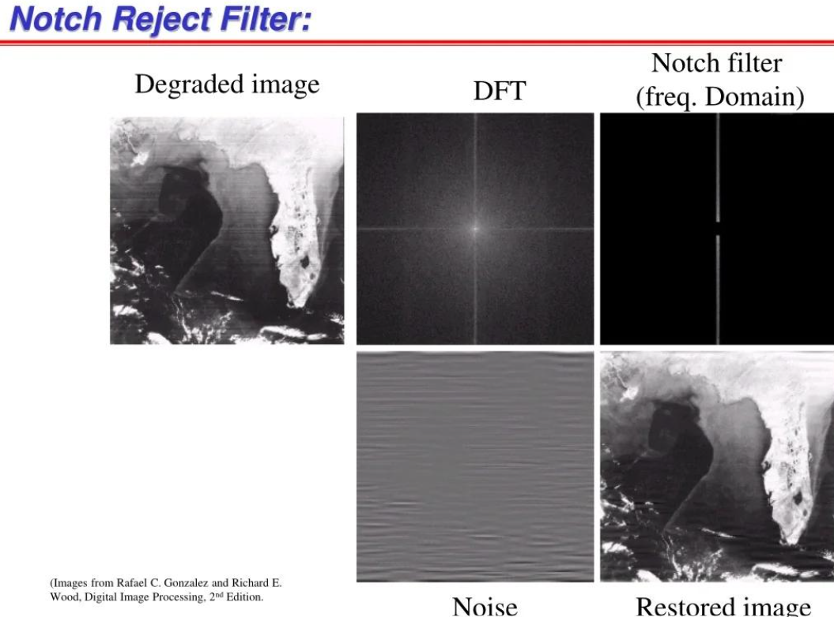

(c) Recommend an appropriate enhancement technique to remove the interference.
Recommended Technique:
Frequency Domain Filtering using a Notch Reject Filter
- Use Frequency Domain Filtering with FFT (Fast Fourier Transform).
- Apply a Notch Reject Filter to remove the periodic horizontal stripe noise.
- Convert the filtered image back using Inverse FFT (IFFT).
- This method removes electrical interference while preserving the important details of the metal component.
- It produces a clearer image for accurate defect detection.


(d) Justify why your selected approach is more suitable than spatial-domain methods.
A Notch Reject Filter is the best choice because:
- It removes only the frequencies responsible for the stripe pattern.
- The actual image information remains almost unchanged.
- Spatial filters (Mean, Median, Gaussian) remove noise everywhere, causing image blurring.
- Frequency-domain filtering is specifically designed for repetitive periodic interference.

(e) Explain your answer in a logical sequence.
Step-by-Step Process
- Capture the metal component image.
- Convert the image into the frequency domain using Fast Fourier Transform (FFT).
- Detect the bright peaks representing periodic stripe noise.
- Apply a Notch Reject Filter to suppress those frequencies.
- Perform the Inverse FFT to reconstruct the clean image.
- Use the enhanced image for accurate defect detection.
Conclusion
Since the interference is periodic, FFT + Notch Reject Filtering removes only the unwanted stripe frequencies while preserving important defect details, making it ideal for industrial quality inspection.

Scenario 2: Autonomous Vehicle Navigation



(a) Interpret the scenario and explain the challenge involved.
The self-driving car captures road images during heavy rain, introducing random noise. At the same time, lane markings, road edges and traffic boundaries must remain sharp for safe navigation.

(b) Identify the importance of preserving edges while removing noise.
Edges contain important information such as:
- Lane detection depends on clear edges.
- Road boundaries help maintain the vehicle's position.
- Traffic sign and obstacle detection require sharp image details.
- Blurred edges may lead to incorrect steering decisions and reduced driving safety.

(c) Recommend a suitable filtering technique.
Recommended Technique:
- Transform the noisy image into the frequency domain using FFT.
- Identify the frequency peaks caused by electrical interference.
- Suppress these frequencies using a Notch Reject Filter.
- Convert the filtered image back using Inverse FFT.
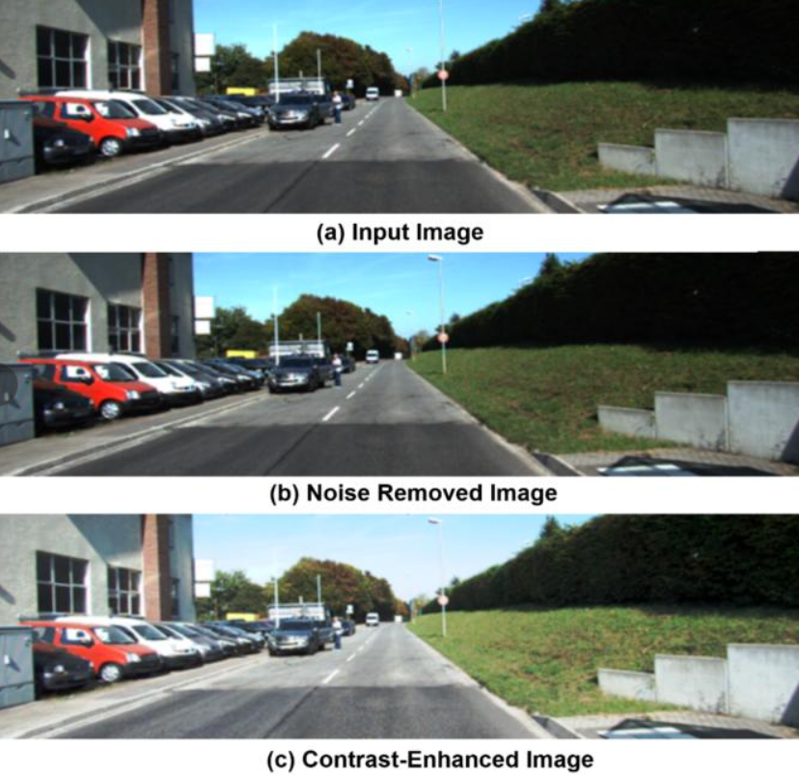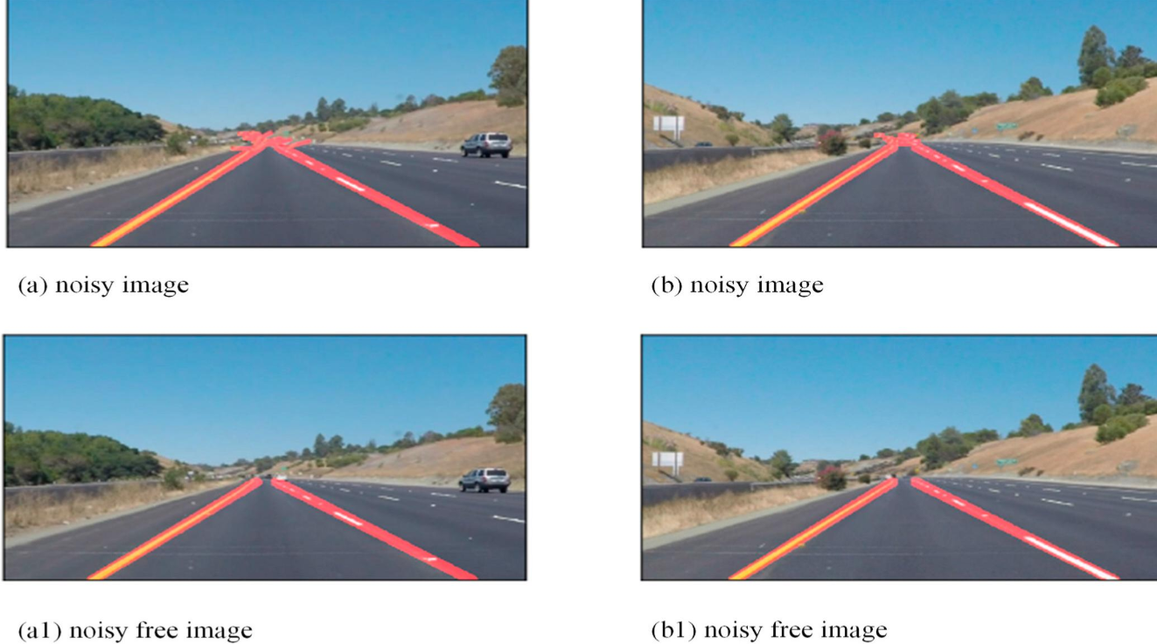

(d) Justify why your selected filter preserves important image details.
The Bilateral Filter is preferred because:
- It smooths noisy regions while preserving edge boundaries.
- It considers both pixel distance and intensity difference.
- Unlike Gaussian or Mean filters, it avoids excessive edge blurring.
- It improves image quality without losing important road features.

(e) Present your explanation clearly and systematically.
Step-by-Step Process
- Capture the road image during rainfall.
- Detect random noise introduced by rain and the camera sensor.
- Apply the Bilateral Filter.
- Reduce noise in uniform regions.
- Preserve lane markings and road edges.
- Pass the enhanced image to the lane detection and navigation system.

Conclusion
The Bilateral Filter effectively removes rain-related noise while maintaining sharp lane boundaries, making it highly suitable for autonomous vehicle navigation.

